EXP NO: 03 Basics of MacOS Forensics NAME : ADHIYAN PERIYAR R P

DATE: 24/07/2025 ROLL NO : 231901002

AIM :

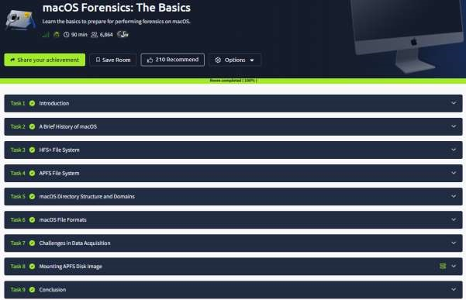

Task 1 : Introduction



Task 2 : A Brief History of macOS

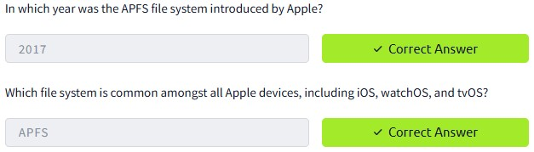

Task 3 : HFS+ File System

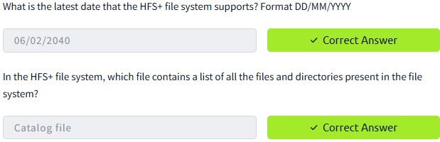

Task 4 : APFS File System

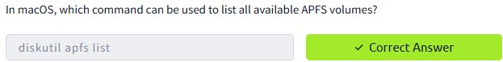

Task 5 : macOS Directory Structure and Domains

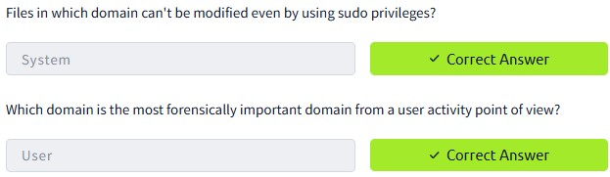

Task 6 : macOS File Formats

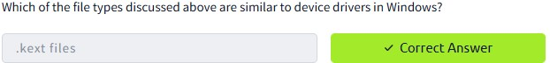

Task 7 : Challenges in Data Acquisition

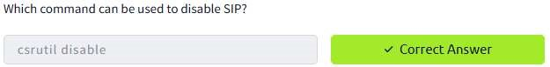

Task 8 : Mounting APFS Disk Image

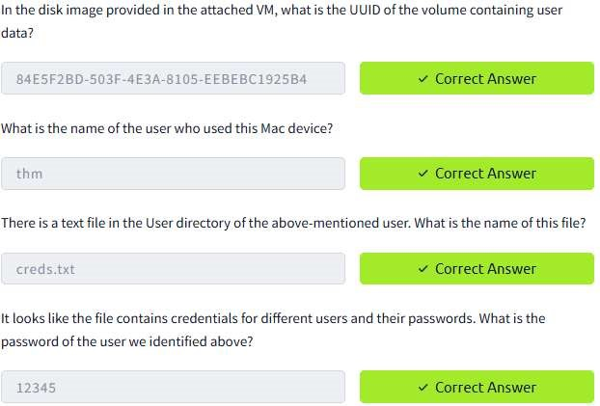

Task 9 : Conclusion



RESULT :

Basics of MacOS Forensics is successfully completed in tryhackme platform.